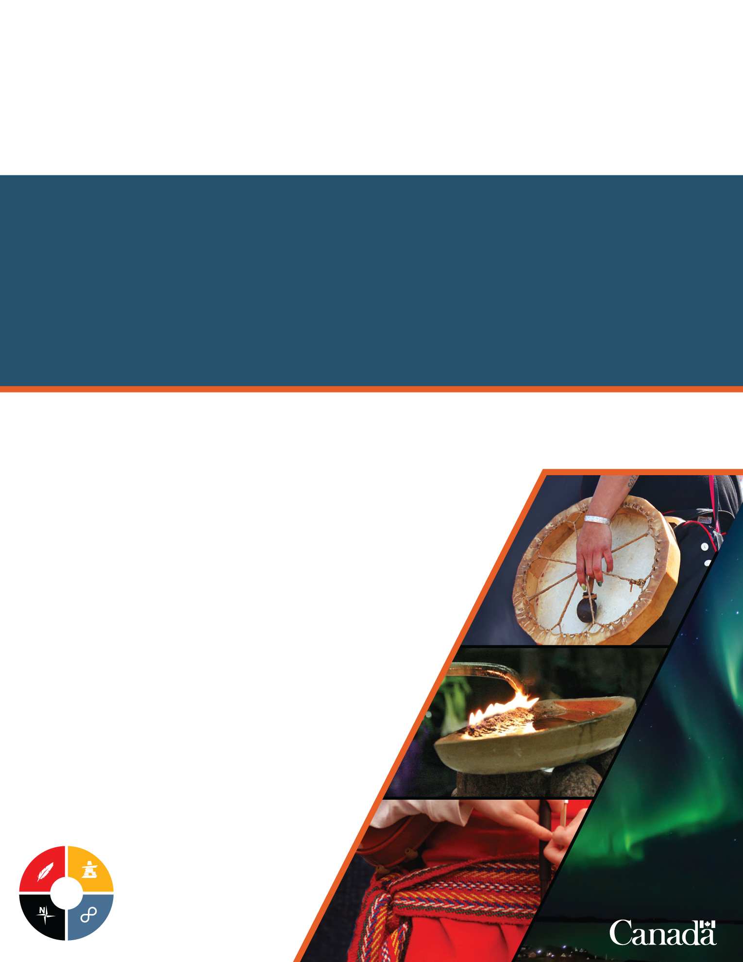

Northern Participant Funding Guide
Meliadine Gold Mine Project – Reconsideration of Terms and Conditions for Project Certificate No. 006
August 2020

Table of Contents
Purpose of this guide 3
Intended users of this guide 3
Content of this guide 3
Contact 3
Overview of Participant Funding 4
What is Participant Funding? 4
When Is Funding Available? 4
Who is Eligible for Funding? 4
What Activities may be Funded? 5
What expenses may be funded? 6
How Does The Participant Funding Process Work? 6
Annex A: Participant Funding Application Form 8
Pre-submission checklist 12
Annex B: How to Complete Your Application Form 13
Part A: Eligibility Checklist 14
Part B: Applicant Information 14
Part C: Work Plan 14
Part D: Expenses 14
Part E: Other Funding Sources 16
How to submit your application 16
Annex C: Anticipated Process for impact assessment of proposed project 17

Purpose of this guide
This guide has been prepared by Crown-Indigenous Relations and Northern Affairs Canada (CIRNAC), a federal department, with input from the Nunavut Impact Review Board (NIRB) for use by participants seeking funding to participate in the NIRB’s reconsideration of the Terms and Conditions of Agnico Eagle Mines Ltd’s Project Certificate No. 006 for Meliadine Gold Mine under both the Nunavut Agreement and relevant assessment provisions of the Nunavut Planning and Project Assessment Act (NuPPAA).
CIRNAC staff are happy to provide advice on the program as you prepare your application, and we strongly recommend that you contact us at aadnc.aidefinanciereparticipants-participantfunding.aandc@canada.ca.

Intended users of this guide
This guide is intended for eligible individuals (see page 4) and organizations interested in participant funding to help them effectively participate in the NIRB’s process.

Content of this guide
This guide contains the following main parts:
- overview of participant funding for the reconsideration of Project Certificate No. 006 for Meliadine Gold Mine,
- application form, and
- guidance on how to complete your application.

Contact
For information about the Northern Participant Funding Program, please contact aadnc.aidefinanciereparticipants-participantfunding.aandc@canada.ca.

Overview of Participant Funding

What is Participant Funding?
CIRNAC’s Northern Participant Funding Program supports effective public participation in impact assessments undertaken by the northern co-management boards in the territories in accordance with the Nunavut Agreement and relevant provisions of Nunavut Planning and Project Assessment Act (NuPPAA). CIRNAC can only provide funding for projects in the three territories; projects in the provinces can be funded by the Impact Assessment Agency, the Canada Energy Regulator, or the Canadian Nuclear Safety Commission.
Funding may be made available to Indigenous governments or groups, or other northerners interested in participating in the assessment. The funding can cover expenses to support participation such as the costs of conducting studies, travel costs and fees for experts. Please note that participant funding is limited and CIRNAC may not be able to cover all expenses incurred by the participant. In order to make best use of program dollars, we encourage every applicant to seek ways of collaborating with other affected parties as well as other sources of available funding.

How and When is Funding Available?
Participant funding will be made available to Indigenous governments or organizations and other northerners for the impact assessment of major resource development or regional infrastructure projects. Some of the factors considered in determining the application of the program include:
- the level of public interest;
- the scale, scope and complexity of the proposed project; and
- the extent of anticipated regional and transboundary impacts.
CIRNAC will announce the availability of participant funding for a project proposal undergoing an assessment at the earliest possible step in the assessment process.

Who is Eligible for Funding?
Participants eligible for funding are:
- Indigenous governments;
- First Nations;
- Inuit;
- Métis;
- Non-status Indigenous peoples;
- Indigenous organizations;
- Community groups;
- Incorporated not-for-profit organizations;
- Experts able to contribute specialized knowledge; and
- Other northern residents or interested affected parties
The Applicant must demonstrate that they meet at least one of the following criteria:
- have Indigenous or Traditional Knowledge, Inuit Qaujimajatuqangit or Qaujimaningit (IQ), an Indigenous perspective, or community knowledge, relevant to the impact assessment;
- have an interest in potential impacts to Indigenous claims, rights, or title;
- plan to provide expert information relevant to the anticipated environmental impacts of the proposed development; or
- have a direct, local interest in the proposed development, such as living or owning property in the development area.
  - Parties Ineligible for Funding
Individuals and organizations are ineligible for participant funding if they:
- are the proponent of the Project, or are one of its subsidiary or parent organizations, or have direct or indirect holdings in the proponent’s organization;
- are a for-profit organization;
- have a direct commercial interest in the proposed project; or
- represent another level of government, other than an Indigenous
government (note: municipal governments may be eligible for funding under certain circumstances).
Although parties may be ineligible for participant funding, they may still be eligible to participate in the assessment, including formal registration as an intervener.
An exception to the restriction on funding groups with a direct commercial interest in a project will be considered if the applicant is an organization that represents Indigenous rights holders or an organization that has been designated any responsibility, power, function or authority under a historical treaty or modern land claim or self-government agreement.
If you have questions about eligibility please contact CIRNAC staff at aadnc.aidefinanciereparticipants-participantfunding.aandc@canada.ca.

What Activities may be Funded?
The following activities may be considered for funding:
- engagement in the scoping phase (e.g., issue scoping sessions, scoping hearings)
- review of the Environmental Impact Statement (EIS) or EIS Addendum submitted by the project proponent and preparation of information requests and technical comments;
- preparation for and participation in public engagement sessions;
- collection, translation, documentation, or transmission of Indigenous Knowledge or IQ;
- review of the proponent’s response to the technical review comments and responses to information requests;
- preparation for and participation in technical meetings and pre-hearing conferences;
- preparation of final written submissions; and
- preparation for and participation in the public hearings.
  - Activities Ineligible for Funding
Funding will not be provided for activities that duplicate services, studies, or written materials being funded by other public or private sources. This includes information prepared by the responsible authorities, proponent, or, in the case of the assessment, by the NIRB itself. Similarly, participant funding cannot pay multiple recipients for substantially identical products or services (for instance, the same report or study).

What expenses may be funded?
Eligible expenses include:
- travel expenses,
- professional fees (e.g. consultants, lawyers, Honoraria),
- non-core staff salaries,
- office supplies or telephone charges, and
- media advertising, and promotion.
Please note that core operations and maintenance expenses are not eligible for funding under participant funding.

How Does The Participant Funding Process Work?
  - Timing for Submitting Participant Funding Application
To apply for participant funding in the NIRB’s reconsideration of Agnico Eagle Ltd.’s Project Certificate no. 006 for Meliadine Gold Mine, an application form must be received by CIRNAC’s Northern Participant Funding Program (NPFP) no later than 11:59pm EDT on Friday September 11th, 2020. The application form associated with the assessment process is available in Annex A of this guide, or by emailing aadnc.aidefinanciereparticipants-participantfunding.aandc@canada.ca.
  - Establishment of Application Review Committee
An independent Application Review Committee will be established by CIRNAC to review applications for participant funding related to the assessment. The Application Review Committee will consist of a minimum of three individuals who have a reasonable knowledge of the project, are aware of the needs of interveners, and have no interests or stake in the project. CIRNAC will work with the Nunavut Government and Nunavut Tunngavik Incorporated to select the Application Review Committee. The Application Review Committee will then work independently to review funding applications, identify groups whose contribution is important for the assessment of the proposed project, and recommend a level of funding required to facilitate their participation.
The Application Review Committee will consider all applications and recommend funding allocations to CIRNAC, with a justification for their recommendations.
  - Allocation of Funding and Announcement of Awards
The Application Review Committee’s determinations and recommendations are forwarded to CIRNAC, who then determine final allocations and send a list of recipient and funding amounts to the NIRB. Subject to available funding and due diligence—primarily ensuring that all activities and expenses are eligible—CIRNAC will generally base its decision on the Application Review Committee’s funding recommendations on who is to be funded. A justification will be documented for any departure from the Application Review committee’s recommendations. As funds are limited, some applicants may not be awarded funding, or may receive less than the amount for which they applied.
Upon receipt of the funding decision, the NIRB posts and distributes the list of successful applicants and amounts awarded on the NIRB’s public registry (www.nirb.ca).
  - Administration of Funding Agreement
Funding is provided by way of a contribution agreement, which:
- identifies the nature of the work to be funded,
- specifies conditions for payment, and
- indicates what reporting the recipient is to submit.
There are three funding approaches available for Indigenous recipients: Set, Fixed and Flexible; program officers and the recipient can discuss the appropriate approach when establishing funding agreements. Non-indigenous recipients are eligible for Set funding agreement. Each funding agreement includes certain terms and conditions as outlined in CIRNAC's national funding agreement models.
The main difference between the three funding approach regards the ability to:
- carry forward funds to the next fiscal period,
- redirect funds to related activities; and,
- retain unexpended funds.
Further explanation of the funding approaches used by CIRNAC can be found at:
https://www.aadnc-aandc.gc.ca/eng/1322746046651/1322746652148
The timing and amount of payments can generally be arranged however best suits the recipient, including the number of payments, how much is advanced, etc. When setting up a funding agreement, NPFP staff will reach out to recipients to discuss their cash flow needs; if circumstances prevent us from having that discussion in a timely manner, NPFP will usually put 10% of the funding in a pool, and the remainder either in equal quarterly payments or in a single advance payment, at the program’s discretion.
Recipients are strongly advised to seek the approval of CIRNAC before making any changes to the original budget submitted with their applications.
As part of the funding agreement, recipients will have to submit an activity report and a financial report, which may need to be an audited financial statement.

Annex A: Participant Funding Application Form
When completing this application, please refer to “How to Complete Your Application Form” of the Participant Funding Guide.
CIRNAC staff is happy to provide advice on the program as you prepare your application, and we strongly recommend that you contact us at aadnc.aidefinanciereparticipants-participantfunding.aandc@canada.ca.
Part A: Eligibility Checklist
Are you, your group, or the organization you represent a for-profit organization? | ☐ Yes ☐ No
Do you, your group, or the organization you represent have a direct commercial interest in the development? | ☐ Yes ☐ No
Do you, your group, or your organization represent another level of government, other than an Indigenous government?* | ☐ Yes ☐ No
*Under certain circumstances, municipal governments may be eligible.
For more information, please email program staff at aadnc.aidefinanciereparticipants-participantfunding.aandc@canada.ca.
If the answer to any of the above questions is yes, you are ineligible for participant funding.
Do you have Indigenous or Traditional Knowledge, IQ, Indigenous perspective, or community knowledge, relevant to the impact assessment? | ☐ Yes ☐ No
Does the proposed project have potential impacts on your asserted claims, rights, or title? | ☐ Yes ☐ No
Do you plan to provide expert information relevant to the anticipated environmental impacts of the project? | ☐ Yes ☐ No
Do you have a direct, local interest in the development, such as living or owning property in the development area? | ☐ Yes ☐ No
If the answer to any of the above questions is yes, you are eligible for participant funding.
Do you, your group, or the organization you represent have any personal, family, or business involvement with the project proponent, or any government departments or agencies involved? | ☐ Yes ☐ No
If so, please explain (1 page maximum)

Part B: Applicant Information
Participation in NIRB’s reconsideration of the Terms and Conditions of Agnico Eagle Mines Ltd’s Project Certificate No. 006 for Meliadine Gold Mine.
Organization Applicants
Name of Organization or Unincorporated Entity
Mailing Address |  | City/Town | Territory | Postal Code
Telephone Number | Fax Number | Email Address
How would you like to be contacted?
☐ Email
☐ Telephone
What unique perspective or role do you bring to the assessment of the project? (see Annex B for more information)
Individual Applicants
Surname (Last name) |  | Full given names
Mailing Address |  | City/Town | Territory | Postal Code
Telephone Number | Fax Number | Email Address
How would you like to be contacted?
☐ Email
☐ Telephone
What unique perspective or role do you bring to the assessment of the project? (see Annex B for more information)
Part C: Work Plan
Describe your proposed activities and objectives and how they will contribute to the NIRB’s understanding of the anticipated effects of the project.

Will you be working with any other groups or organizations involved in the assessment or affected by the proposed project? If so, please list.

Part D: Expenses
Travel Expenses
Item | Description |  |  |  | Estimated Cost
Transportation
Accommodation
Per diems
Other (please specify)
Summarize the objective of travel

No. of travelers
Professional Fees (including legal experts and Honoraria)
Type of professional |  | Fees | Other Expenses (e.g. travel or accomodations) | Total Cost

Please note that the Northern Participant Funding Program no longer subjects Honoraria to a $200 limit.

Staff Salaries
Position Title | Total Cost
Office Supplies and Telephone Charges
Office Supplies and Telephone Supplies | Description |  | Total Cost
Media, Advertising, and Promotion
Action/Item |  | Description |  | Total Cost
Other Expenses
Action/Item |  | Description |  | Total Cost
Part E: Other Funding Sources
Have you applied or will be applying for funds from other sources to participate in the assessment process? | ☐ Yes ☐ No
If yes, please specify funding level and the source.
Total Requested Funds*:__________
*Please note that proposals can be funded up to $150,000 per project per fiscal year (April 1st to March 31st).
The information provided in this application may be shared with the NIRB and the Application Review Committee], and is protected under the Privacy Act and the Access to Information Act.
If you wish to apply for Participant Funding without using this form, please ensure that your application contains all the information requested in the form.

Pre-submission checklist
Please use this checklist to help ensure that your application is complete so that there are no delays in reviewing your application for funding.
  - Checklist
☐ Part A: Eligibility Checklist is completed
☐ Part B: Applicant Information is completed
☐ Part C: Work Plan is completed
☐ Part D: Expenses is completed and detailed information regarding costs and a proposed budget is included in your submission.
☐ Budget calculations are complete, correct, and clearly explained where appropriate.
☐ Part E: Other Funding Sources is completed
☐ Ensure your proposal is submitted to aadnc.aidefinanciereparticipants-participantfunding.aandc@canada.ca prior to 11:59pm EDT on Friday September 11th, 2020.

Annex B: How to Complete Your Application Form
This section of the guide presents step-by-step instructions for completing and submitting the Participant funding Application Form:
  - Part A: Eligibility Checklist
  - Part B: Applicant Information
  - Part C: Work Plan
  - Part D: Expenses
    - Travel Expenses
    - Professional Fees
    - Staff Salaries
    - Office Supplies and Telephone Charges
    - Media, Advertising, and Promotion
    - Other Expenses
  - Part E: Other Funding Sources
  - How and where to submit your application
  - Checklist for Completing the Funding Application Form
For a copy of the application form, please refer to Annex A

Part A: Eligibility Checklist
This checklist helps identify if your organization is eligible to receive participant funding.
If you meet the eligibility for funding requirements in the checklist, please proceed to the next section.

Part B: Applicant Information
- If you are seeking funding on behalf of an organization, complete the information for “Organization Applicants” only.
- If you are an individual seeking funding, complete the information for “Individual Applicants” only.
As part of this section, we ask that you please describe the unique and important perspective or role that you or your organization bring to this assessment. Applicants should also demonstrate that they have at least one of the following:
- a direct, local interest in the development, such as living or owning property in the development area;
- an interest in potential impacts to related claims and rights;
- Indigenous or Traditional Knowledge, IQ, Indigenous perspective, or community knowledge, relevant to the impact assessment; or
- expert information relevant to the anticipated environmental impacts of the development.

Part C: Work Plan
- Provide a clear statement of your proposed funding to the assessment, including:
- the objectives of your participation,
- your proposed activities for each phase of the assessment, and
- how these objectives and activities may contribute to the NIRB’s understanding of the project’s anticipated effects.
For a detailed description of the phases and steps involved in the assessment process, applicants are encouraged to review Annex C and any project-specific correspondence issued by the NIRB.

Part D: Expenses
Travel Expenses
This includes expenses related to traveling to attend public participation events held as part of the assessment, including transportation, meals, lodging, and incidentals.
Under “Description”, provide itemized details (e.g. $___ x ___days x ___ people = $___) on the transportation, accommodation, per diems (daily allowances for meals and incidentals while on travel status, subject to the maximum rates set out by the National Joint Council Travel Directive - Appendix C) and any other travel-related expense.
In the last two rows of this section, summarize the objective of travel and the number of travelers.
Please keep in mind that travel expenses should be reasonable and in accordance with federal government travel directives.
Professional Fees (including legal experts and Honoraria)
This covers expenses for legal advice, and expert advice or assistance on environmental, technical, or social issues relevant to the objectives of the assessment.
This includes per diem fees, Honoraria, or fees for experts or elders providing Indigenous or Traditional Knowledge, IQ, or community knowledge relevant to the assessment.
Professional services directly related to your participation, such as accounting, translation, or interpretation, are also covered.
For each expert, provide:
- the type of professional,
- professional’s fees (including rates and number of days, or the like),
- other expenses (including per diems, travel, and accommodations for the professional, and number of days), and
- the total cost.

Please note that the Northern Participant Funding Program no longer subjects Honoraria to a $200 limit.
Staff Salaries
This includes the salaries of individuals employed for the purpose of researching and preparing materials related to your participation (e.g., research staff and secretarial services). Note that we may only fund salaries for an individual who is not currently receiving a salary, or to temporarily cover the costs of replacing an individual who is receiving salary. Please provide the position title and the total cost for each individual.
Office and Telephone Expenses
This covers the cost of office expenses such as photocopying and postage, and communication charges such as telephone, teleconferencing, and information technology expenses.
Any office expenses that do not support your participation in the assessment (e.g. normal supplies and overhead) are not eligible for funding under the program
Please provide the name of each expense, a brief description of how it relates to your participation in the assessment, and the total cost of the expenses.
Media, Advertising and Promotion
This covers advertising for the purpose of publicizing meetings and activities related to the assessment (e.g., posters, newspaper advertisements, radio announcements, etc.).
The advertising should have a specific purpose that has not already been addressed by other parties with the responsibility to promote awareness of the assessment or public participation opportunities.
Please specify what type of media, describe how it contributes to the objectives of the assessment, and the total cost.
Other Expenses
Any other expense that is needed to support your participation in the assessment may be covered by this category.
Please specify the action or item, provide a clear explanation of how this item will contribute to the objectives of the assessment, and show the total cost associated to the expense.

Part E: Other Funding Sources
In order to assess the level of funding, please state whether you have applied for financial support from any other source to fund your participation in the assessment. Please provide information about the funding source and their level of support.

How to submit your application
Submit your application to aadnc.aidefinanciereparticipants-participantfunding.aandc@canada.ca after completing all items in the checklist on page 13. To be considered for funding, applications must be received by electronic mail on or before 11:59pm EDT on Friday September 11th, 2020. If you have any further questions or concerns about your application, please contact aadnc.aidefinanciereparticipants-participantfunding.aandc@canada.ca for direction.

Annex C: Anticipated Process for impact assessment of proposed project

Please refer to the NIRB’s public registry at https://www.nirb.ca/project/124106 for the latest details on the process steps for the reconsideration of Project Certificate No. 006 for Meliadine Gold Mine.

